Writer properties
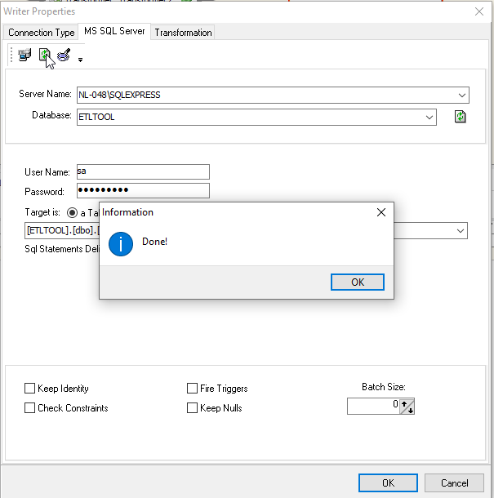

Transformation Tab
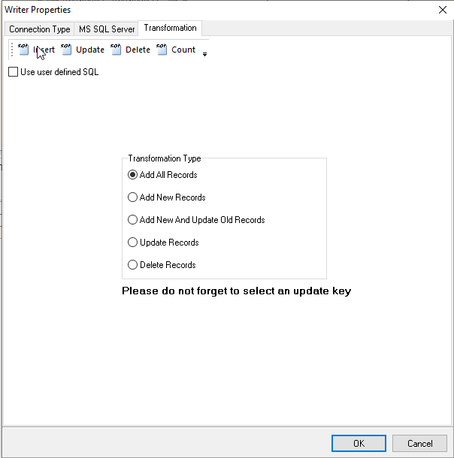
When I look at the insert-statement, I see that it wants to inset values in my SQLExpress table with values ?,?,?,?,? (etc):
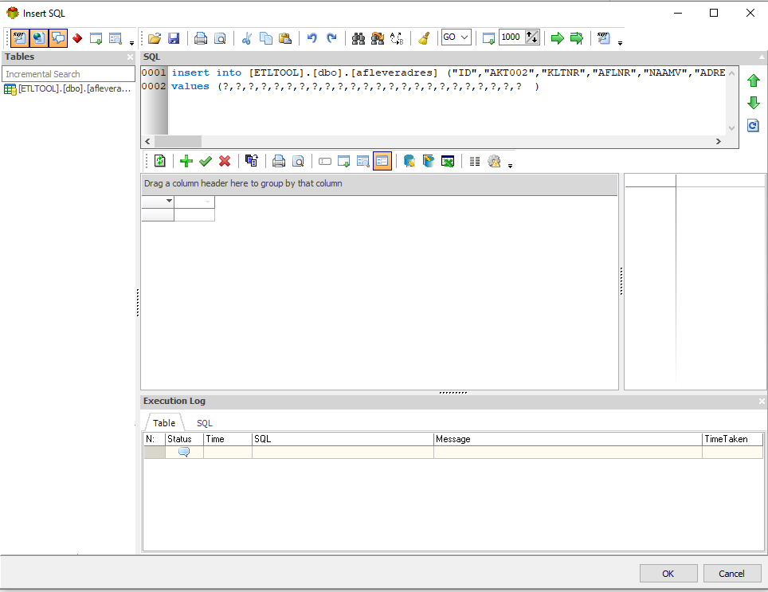

When I execute a run of 5 records, it shows me the following execution log:
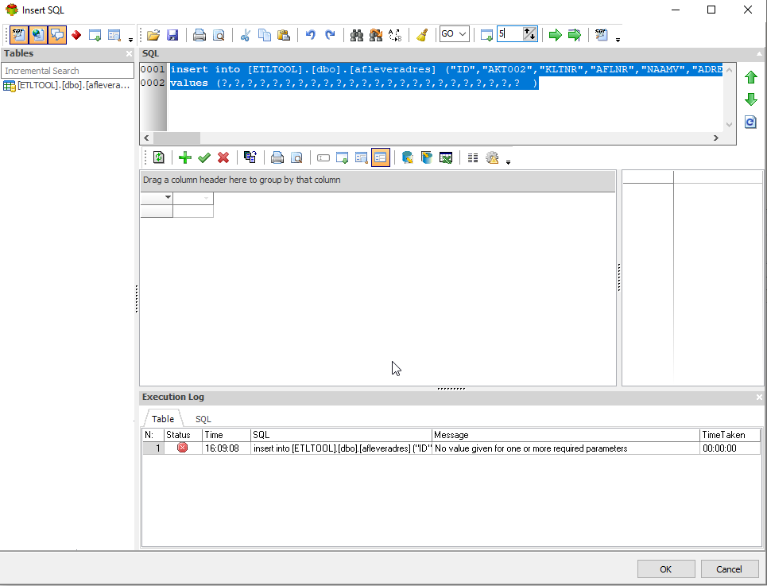

Am I doing something wrong?

